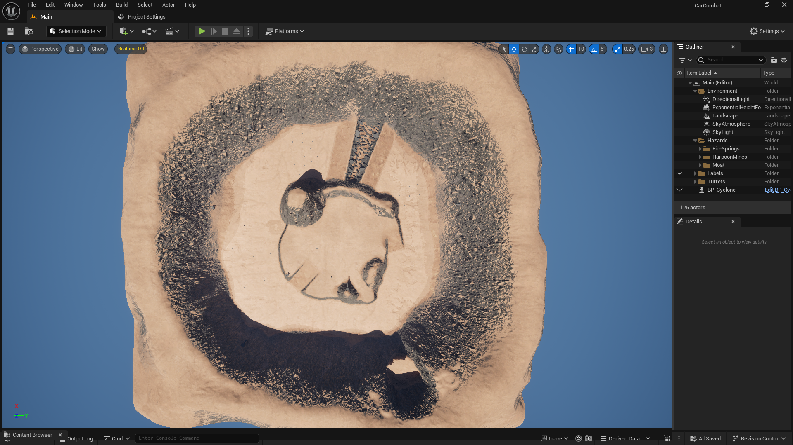
- Start
- Machine Guns
  - Attack a target within a limited angle
  - Have low precision
- Missile Turrets
2
  - When locked on a target, fire homing missiles
  - Recharge takes a long time
- Moat
  - Instantly destroys the player
- Harpoon Traps
  - Get triggered when the player is close
  - Restrict player`s movement until get destroyed
- Fire Springs
6
6
5
5
4
3
3
3
2
2
2
2
2
2
1
  - Deal continuous damage to the player while they are in fire
  - The emission lasts for 2 seconds, then it stops for 3-6 seconds

